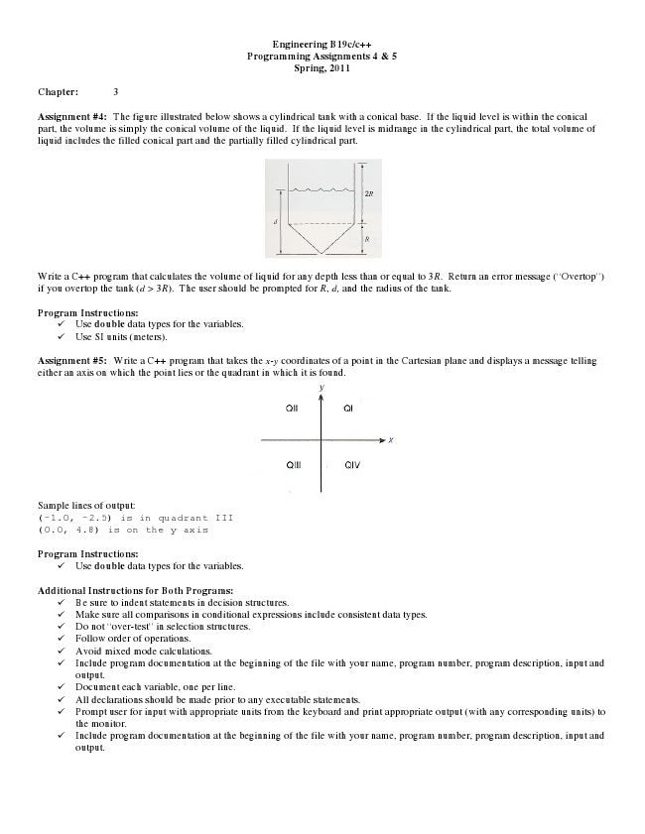

**Engineering B19c/c++ Programming Assignments 4 & 5 Spring, 2011**

**Chapter: 3**

Assignment #4: The figure illustrated below shows a cylindrical tank with a conical base. If the liquid level is within the conical part, the volume is simply the conical volume of the liquid. If the liquid level is midrange in the cylindrical part, the total volume of liquid includes the filled conical part and the partially filled cylindrical part.

Write a C++ program that calculates the volume of liquid for any depth less than or equal to 3R. Return an error message (“Overtop”) if you overtop the tank (d > 3R). The user should be prompted for R, d, and the radius of the tank.

**Program Instructions:**

✓ Use double data types for the variables. ✓ Use SI units (meters).

Assignment #5: Write a C++ program that takes the x-y coordinates of a point in the Cartesian plane and displays a message telling either an axis on which the point lies or the quadrant in which it is found.

Sample lines of output: (-1.0, -2.5) is in quadrant III (0.0, 4.8) is on the y axis

**Program Instructions:**

✓ Use double data types for the variables.

**Additional Instructions for Both Programs:**

✓ Be sure to indent statements in decision structures. ✓ Make sure all comparisons in conditional expressions include consistent data types. ✓ Do not “over-test” in selection structures. ✓ Follow order of operations. ✓ Avoid mixed mode calculations. ✓ Include program documentation at the beginning of the file with your name, program number, program description, input and

output. ✓ Document each variable, one per line. ✓ All declarations should be made prior to any executable statements. ✓ Prompt user for input with appropriate units from the keyboard and print appropriate output (with any corresponding units) to

the monitor. ✓ Include program documentation at the beginning of the file with your name, program number, program description, input and

output.